Human Performance
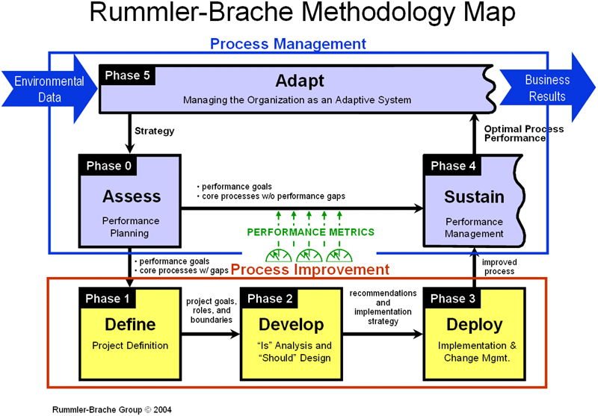

In Talent, we believe that workforce readiness is a critical component of successful asset performance. Talent has a highly skilled human performance and training experts to connect asset owners and operators with the solutions needed to ensure workforces are competent and ready to operate assets safely and efficiently.
Our human performance management system is a highly effective tool that is flexible and can be tailored for sites or specific operational teams. We are delivering tailored human performance systems for customers, through to five phases (ASSESS – DEFINE –DEVELOP-DEPLOY– SUSTAIN) to develop a performance metrics for entire workforces.

Talent ‘hands on experience
- Training Management and Talent Compass© implantation
- Role and task analysis
- Operating manuals and procedures
- Competency Assurance Management Systems (CAMS)

